Patient Information

Mr./Mrs./Ms/ Last Name: _______________________________ First Name: ________________________________

Birthdate(D/M/Y): ____________________ Marital Status:  Single  Married  Divorced  Widowed Separated

Address: __________________________________________City: ________________ Postal Code: _______________

Home tel. # ____________________________ Work tel. #: _____________________________ Ext.______________

Cell tel. #:____________________________ Email:______________________________________________________

Preferred method of contact:  home  work  cell  email Preferred appt.day/time _________________________

Emergency contact: _______________________Relationship:_______________ Tel. #__________________________

Referred by: Flyer / Sign / Website / Patient _________________________  Other________________________
(Please circle one)
Dental Insurance Information

Primary Carrier:
Policy holder’s Last name: _________________________________ First Name: _______________________________

Relationship to patient:_______________________________ Birthdate (D/M/Y): _____________________________

Employer: ____________________________________ Insurance company: __________________________________

Group/Policy #:______________________ ID/Certificate #: _____________________________________________

Secondary Carrier
Policy holder’s Last name: ________________________________ First Name: ________________________________

Relationship to patient:_______________________________ Birthdate (D/M/Y): _____________________________

Employer: __________________________________ Insurance company:_ ___________________________________

Group/Policy #:______________________ ID/Certificate #: _____________________________________________

On occasion, our office will distribute newsletters by email which may include valuable dental health information, important updates regarding impressions dental and fabulous promotions. We also use your email address to confirm your dental appointments. If you have not included this information previously, please provide it now.

Medical History

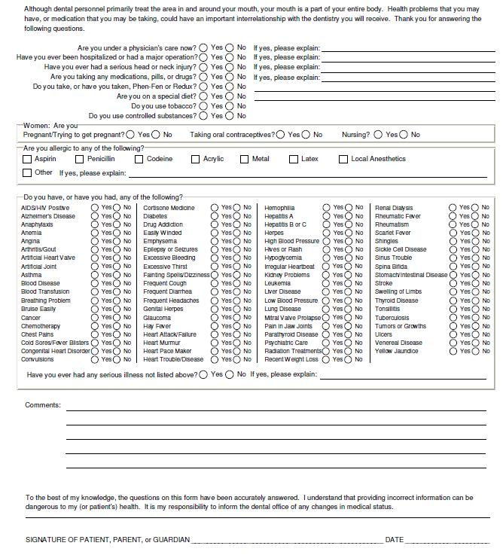
If you are taking any medications, please provide details of the medications, including the dose and frequency and the reason for use: _______________________________________________________________________________

Dental History

1. What is your primary concern with your teeth/smile? ____________________________________________________
_______________________________________________________________________________________________

2: Are you happy with the appearance of your teeth/smile? _________________________________________________
_______________________________________________________________________________________________

3. How would you like us to help you? _________________________________________________________________
_______________________________________________________________________________________________

4. Are you anxious about having dental treatment? If so, what is your biggest concern? ___________________________
_______________________________________________________________________________________________
_______________________________________________________________________________________________

Do you have, or have you had, any of the following?

Discomfort or pain? 
Tooth sensitivity to hot or cold? 
Headaches, earaches or neck aches? 
Problems with your jaw joints? 
Problems with your bite? 
Serious trouble associated with previous dental treatment? 

Please explain:
_______________________________________________________________________________________________

_______________________________________________________________________________________________

_______________________________________________________________________________________________

Additional Information

Is there anything in your medical and dental history that we have not specifically asked about that we
should be made aware of? If so, please explain: _______________________________________________________________________________________________
_______________________________________________________________________________________________
_______________________________________________________________________________________

Thank you for choosing impressions dental for your dental care needs. Please read through the following page and sign where indicated, acknowledging that you understand our policies and agree to comply with them. We welcome your questions and comments and are committed to providing exceptional dental care to all our patients. We appreciate the confidence you place in us.

Dental Insurance

We accept most dental insurance benefits and payments are assigned directly to the office. Your co-insurance payment, including any deductible as well as the percentage not covered by your carrier, is due at the time of service. Your co-insurance payment is calculated by information you have provided and/or information received from your dental carrier. Please note that your dental insurance policy is a contract between you and your insurance company; we are not a party to that contract. We do not have your dental coverage information on file unless you have provided this to us. We accept assignment of benefits as a courtesy to you. Any claim not paid by your insurance carrier within 60 days will be billed to you.

Appointment Cancellations

Please provide 2 business days notice when cancelling or changing an appointment. Failure to provide such notice compromises the service that we deliver to our patients. If inadequate notice has been provided, a cancellation fee will apply. Our answering machine does not accept cancellations. You must speak to a member of our team to cancel or change your appointment.

Authorization & Release

I authorize and request the performance of dental services for myself or for the listed dependant. I will be informed of the need for additional treatment and its fee.

I authorize and request my insurance company to pay impressions dental directly any insurance benefits otherwise payable to me. I understand that my dental insurance carrier may pay less than the total claim amount for services. I agree to be responsible for payment of all the services rendered on my behalf or my dependents.

I authorize impressions dental to submit my dental claims, electronically, to my insurance company on my behalf and obtain necessary insurance information as is pertinent to my treatment.

I give consent to any advisable and necessary dental procedure, medications or anesthetic to be administered by the attending dentist or by her supervised staff for diagnostic purposes or dental treatment. Records may include study models, photography and/or x-rays, which may be used for dental education and/or used in dental publications.

Accounts 90+ days in arrears will be forwarded to an external collecting agency.

To my knowledge, I have given an accurate medical and dental history.

I have read the above and understand fully, the policies as outlined.

Signature of Patient/Guardian: _____________________________________________________

Date :_________________________________________________________________________

Signature of doctor: ______________________________________________________________

